IT Professional Services Work Order

IT PSA

WORK ORDER

Work Order No. _019_ - Upgrade and modernize SAP Global Trade Services (GTS) platform PO#
This Work Order is entered into by and between Eli Lilly and Company (“Lilly”) and _Crave InfoTech LLC (“SDD Partner”) signing below pursuant to the _IT PSA between the parties effective

_12/01/2022
, (the “Agreement”), and is subject to the terms and conditions of the Agreement. This

Work Order is effective as of the last date of signature below. No chargeable work shall commence or accrue prior to such date. Capitalized words that appear in this Work Order are defined in the Agreement.

Description of Services

This work order is for the modernization of the SAP GTS platform as per the strategy and phases given below:

  - Build a centralized, future-ready global trade platform utilizing standard SAP GTS functionalities.
  - Facilitate efficient management of export, import, and duty savings programs.
  - Standardize and automate trade processes, while maintaining the flexibility to localize for different countries.
  - Minimize compliance risks and reduce manual interventions through system-driven controls and comprehensive reporting.
  - Establish a platform that supports global scalability and rapid responsiveness to regulatory changes.

Implementation Strategy
The project will be delivered in phases, each with clearly defined milestones. The implementation phases are:

Phase 0: Requirements & Blueprint
Phase 1: Compliance & Customs Export Template Phase 2: Customs Import and Broker Integration Phase 3: Duty Savings Program (FTZ, IPR and FTA) Phase 4: Global Roll-out and Country Localization

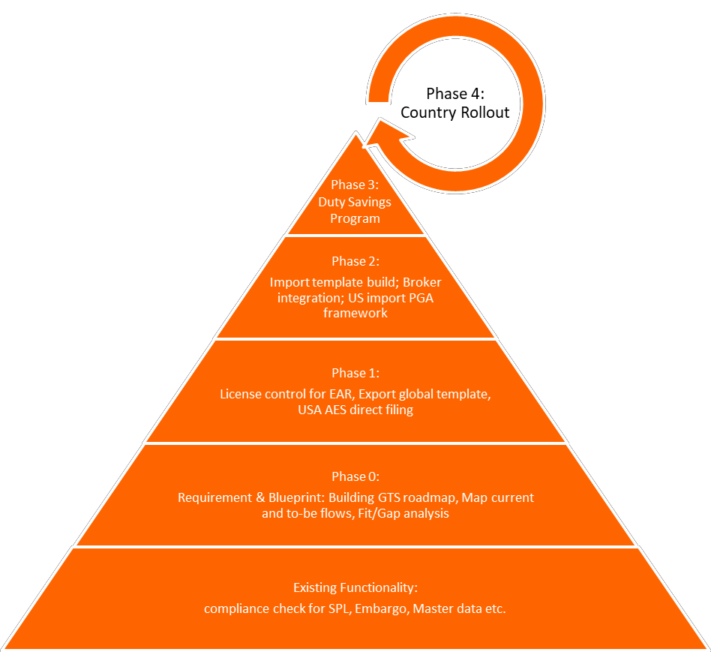

Every phase will include configuration, integration, testing, training, cutover, and hyper care activities to ensure a stable and successful implementation.

Implementation Roadmap
Based on industry’s best practices, prior implementation experience, and our discussions with Lilly, the following represents the proposed roadmap for the GTS rollout along with a detailed phased implementation approach. We have come up with two options for you to consider for this initiative. Respective pros and cons are listed for each option below.

Option 1:

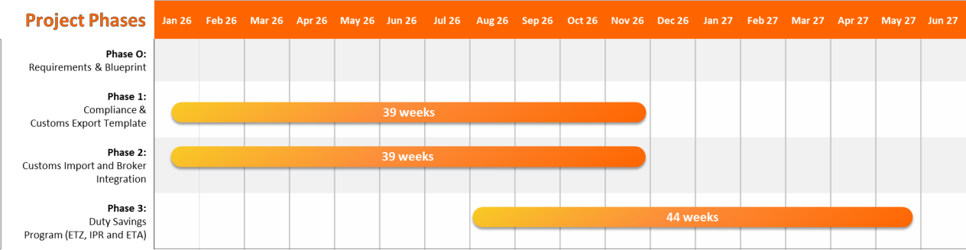

Description:

Both import and export functionalities are built and deployed in parallel, with a single go-live for both processes. This phase is followed by FTZ, IPR and FTA. Business starts using the entire solution at the same time.

Pros:

    - Full functional coverage from Day 1 — both Import and Export available.

    - Accelerated realization of business value.

    - Streamlined training and communications can be aligned to one cutover event.

    - Reduced overall project calendar time. Cons:
    - High change management impact — users must adapt to two new
processes simultaneously.

    - Increased complexity in testing, cutover, and hyper care.

    - Greater risk of operational disruptions during go-live if issues arise in either stream.

    - 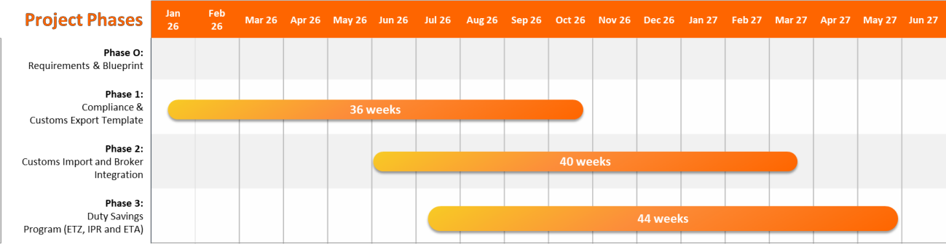Heavier dependency on business readiness and resourcing. Option 2:

Description:

Export functionality is built and deployed first. Once export processes stabilize in production, the import build and deployment follow in a second phase. Import phase is staggered with FTZ, IPR
& FTA

Pros:

    - Smoother change management — business adapts to one process at a time.

    - Learnings from the export deployment can be leveraged to optimize the import build.

    - Lower risk during each go-live phase.

    - It is easier to manage training, testing, and hyper care with phased focus. Cons:
    - Longer overall project timeline.

    - Businesses won’t have full import functionality from the start.

    - Requires sustained engagement of project and business teams over two phases.

Phase 0: Requirement & Blueprint
  - Scope: Conduct global requirements gathering, create “to-be” process maps, perform fit-gap analysis, and identify WRICEF (Workflow, Reports, Interfaces, Conversions, Enhancements, Forms) items.
  - Deliverables: Develop a comprehensive GTS roadmap, fit/gap register, and detailed blueprint and solution design.

Phase 1: Compliance and Export Template

Scope of Work

The primary focus of this phase is to establish the export compliance foundation within SAP GTS, integrate with TMS, and enable automated U.S. AES filing. Key activities include:
- Export Master Data & Configuration
  - Configure export-relevant master data objects
  - Define legal regulation framework for U.S. exports (EAR).
  - Set up control settings for license determination and embargo/sanction checks.
  - Establish standard organizational units and document structures for export processing.
- License Control & Regulatory Compliance
  - Implement EAR license determination logic and integration with legal control checks.
  - Configure license types, usage rules, and exception handling workflows.
  - License setup for healthcare device/drug registration check for exports
  - License load will be automated using standard license tools
  - Set up license assignment rules and automated blocking and integration with S4 process.
- Export Customs Template
  - Setup classification framework for US and other countries.
  - Develop a standardized export customs declaration template to streamline future country
rollouts.

  - Define and map export data elements required for AES submission.
  - Export data element required for US self-filling will be passed via standard GTS data
transfer or via defaulting rules
  - Create re-usable configuration objects for declaration types, procedures, and routing.
- AES Filing Automation
  - Integrate SAP GTS with U.S. Automated Export System (AES) via Seeburger.
  - Automate submission, status monitoring, and response/error handling.
  - Enable standard GTS dashboard for AES status tracking and compliance reporting.
  - Configure message mapping, partner profiles, and IDoc processing.
- Export Documentation
  - Generation of shipping documents Shipper’s Letter of Instruction (SLI), Certificate of Origin (COO), and other required export documents.
  - Enable document archiving and linkage with customs declarations.
  - Support print, email, or EDI distribution.
- Integration with Transportation Management (TMS)
  - Establish interface between SAP TM and GTS for shipment-level AES filing.
  - Automate export declaration creation based on transportation events.
  - Support shipment consolidation using standard GTS process and no-touch filing processes.
- Exception Management
  - Define process flows for exception handling (e.g., license errors, AES rejects, missing data).
  - Configure alerts, workflow routing, and resolution tracking. Testing & Cutover Activities
- Unit Testing
  - Validate configuration objects (master data, license control, AES integration).
  - Test standard export declaration scenarios and document generation.
- Integration Testing (IIT)
  - Validate end-to-end data flow between SAP GTS, ECC/S4, and TMS.
  - Confirm AES filing via Seeburger and verify return messages.
  - Test exception handling and escalation workflows.
- User Acceptance Testing (FIT)
  - Execute business scenarios with key user groups (Trade Compliance, Logistics, Customer Service).
  - Validate reporting, dashboard visibility, and audit trail.
  - Document issues and implement fixes.
- Cutover Planning & Execution
  - Freeze and migrate required export master data and license records.
  - Prepare go-live checklists and signoffs.
  - Execute controlled deployment and monitor system readiness.
- Training & Change Management
  - Develop training materials and quick reference guides for compliance and logistics users.
  - Conduct classroom and virtual training sessions.
  - Provide role-based training for super users and business owners.
- Go-Live & Hypercare
  - Execute final system validation and cutover.
  - Provide hyper care support for stabilization and issue resolution.
  - Monitor AES filings and resolve exceptions in real time.

Phase 2: Customs Import and Broker Integration

Scope of Work

The focus of this phase is to establish a robust import customs framework, implement the Partner Government Agency (PGA) requirements, broker integration through EDI, and build a scalable import customs template to support future rollouts.
- Import Master Data & Configuration
  - Configure import-related master data objects (e.g., business partners, plants, ports of entry, customs offices, importers of record).
  - Define legal regulation framework for U.S. and relevant import countries.
  - Establish valuation settings, Incoterms, and duty calculation logic.
  - Configure customs procedure codes, tariff codes, and import control parameters.
- PGA Framework Implementation
  - Identify applicable Partner Government Agencies (FDA and USDA) and data elements required for each PGA.
  - Configure and enable PGA data capture for regulated commodities.
  - Build PGA database repository.
- Import Customs Template
  - Develop a standard import customs declaration template for U.S. imports and future global deployments.
  - Configure import declaration types, procedures, routing rules, and data mapping. o Establish a scalable structure to accommodate multiple brokers and trade lanes. o Enable reuse of template objects to reduce configuration time in future phases.
- Broker EDI Integration
  - Configure EDI interfaces for electronic communication with customs brokers using standard delivered XML templates.
  - Define message mapping, partner profiles, and processing logic for Importer centric or broker centric filling
  - Automate status updates from broker systems to SAP GTS for real-time visibility.
  - Configure alerting and exception handling for rejected or delayed entries.
- Integration with S/4HANA
  - Enable seamless data flow between S/4 and GTS for purchase orders, inbound deliveries, and goods receipts.
  - Automate creation of import declarations from inbound logistics events using GTS worklist features.

Testing & Cutover Activities

- Unit Testing
  - Validate import configuration objects including PGA framework, broker integration, and import declaration template.
  - Test inbound processing scenarios (PO to customs entry).
- Integration Testing (IIT)
  - Verify end-to-end flow between S/4, SAP GTS, and broker systems.
  - Test broker EDI transactions, and exception handling.
  - Validate integration with import master data and customs procedures.
- User Acceptance Testing (FIT)
  - Involve Trade Compliance, Logistics, Procurement, and Customs Operations teams.
  - Execute real-life import scenarios across different trade lanes and commodities.

  - Validate import workflows, dashboards, and reporting.
- Cutover Planning & Execution
  - Freeze and migrate import master data and broker configuration records.
  - Prepare cutover runbook and rollback procedures.
  - Coordinate deployment with business and IT stakeholders.
- Training & Change Management
  - Develop user training materials covering import declaration creation, PGA filing, and broker EDI monitoring.
  - Conduct role-based training for super users and business operations teams.
  - Provide quick reference guides and troubleshooting checklists.
- Go-Live & Hypercare
  - Execute final cutover and system validation.
  - Monitor PGA filings, broker EDI transactions, and exception cases in real time.
  - Provide dedicated hyper care support for issue resolution and process stabilization.

Phase 3: Duty Savings Program (FTZ, IPR and FTA)

Scope of Work

This phase focuses on implementing a comprehensive duty savings strategy leveraging Foreign Trade Zones (FTZ) in the U.S., Inward Processing Relief (IPR) in Ireland, and Free Trade Agreements (FTA) such as USMCA. The objective is to maximize duty deferral, reduce import/export costs, and enhance compliance automation through SAP GTS.

- Master Data & Configuration
  - Define and configure Foreign Trade Zone sites, zones, subzones, and operators in SAP GTS.
  - Establish FTZ-specific legal regulations, admission types, and FTZ status codes.
  - Configure FTA admin units, legal regulations for FTAs in scope. Setup BOM, Price and
master data transfer to GTS
  - Configure IPR customs ID and relevant data master data setup
- FTZ Framework & Transactional Processes
  - Design and implement inbound admission processes.
  - Configure internal FTZ inventory movement processes.
  - Enable export and domestic consumption withdrawal processes.
  - Integrate FTZ transactions with warehouse and logistics execution processes in S/4.
  - Configure electronic communication with customs brokers for FTZ-related filings or re-use
standard interface to connect to internal FTZ tool.
  - Build FTZ reports to track inventory balances, zone status, and movement history.

- IPR Implementation (Ireland)
  - Establish IPR process framework for Ireland to allow suspension of customs duties on imported goods intended for processing and re-export.
  - Configure IPR authorizations, inward processing movements, and discharge processes.
  - Support reconciliation between inbound materials and re-exported finished goods.
- FTA Enablement (USMCA)
  - Configure FTA determination and qualification rules for USMCA.
  - Enable automated origin calculation and preference determination in SAP GTS.
  - Manage supplier declarations, long-term supplier statements, and origin tracking.

- Integration with Upstream Systems

  - Integrate with S/4 for purchase orders, inbound deliveries, production orders, and inventory postings.
  - Ensure master data transfer relevant for each of the process i.e. BOM, Prices, material attributes

Testing & Cutover Activities

- Unit Testing
  - Validate FTZ, IPR, and FTA configuration including duty calculation, admission/withdrawal, and broker EDI mappings.
  - Test status transitions and exception workflows.
- Integration Testing (IIT)
  - End-to-end validation between GTS, S/4, and broker systems.
  - Test FTZ (admission/withdrawal), IPR inward processing, and USMCA FTA
determination.
  - Confirm broker EDI transmissions and acknowledgments.
- User Acceptance Testing (FIT)
  - Engage Trade Compliance, Logistics, Customs, and Finance teams. o Execute business scenarios across FTZ, IPR, and FTA workflows. o Validate dashboards, reporting accuracy, and compliance outputs.
- Cutover Planning & Execution
  - Migrate FTZ/IPR master data and FTA preference records.
  - Prepare cutover runbook and rollback plans.
  - Coordinate go-live with compliance and IT stakeholders.
- Training & Change Management
  - Deliver training on FTZ/IPR operations and FTA preference management.
  - Provide role-based sessions for compliance, logistics, and finance.
  - Share job aids and escalation playbooks.
- Go-Live & Hypercare
  - Execute deployment and go-live validation.
  - Monitor FTZ/IPR/FTA processes and filings in real time.
  - Provide hyper care support for issue resolution and stabilization.

Phase 4: Roll-out and Country Localization

Scope of Work

This phase focuses on expanding the SAP GTS solution to new countries or regions by localizing existing export and import templates, ensuring compliance with country-specific trade regulations, and driving consistent global processes.
- Country Localization
  - Adapt and extend existing export and import templates to meet local regulatory and customs requirements.
  - Configure country-specific legal regulations, license types, document formats as applicable.
  - The localization timeline is based on extending the current global framework. Additional analysis will be performed to assess country complexity, regulatory depth, and any special local requirements, which may influence the overall implementation effort.

- Process Standardization & Scalability
  - Reuse the global GTS core framework established in earlier phases to accelerate deployment.
  - Standardize trade processes to ensure global consistency, simplify governance, and reduce maintenance overhead.
- Testing & Readiness (IIT and FIT)
  - Conduct regression testing to ensure global processes remain stable as new countries are added.
  - Validate localized configuration and integration points for each region.
  - Perform targeted FIT with regional users for critical country-specific scenarios.
- Training & Cutover
  - Deliver focused training for regional users and key business stakeholders.
  - Execute cutover activities, including data readiness and go-live preparation.
  - Provide country-specific quick reference guides and operational job aids.
- Hypercare
  - Monitor transactions post go-live and address localization-specific exceptions.
  - Stabilize operations and transition to business support.

Reporting and Analytics:

- All reporting requirements will be addressed primarily through standard SAP-delivered content, utilizing Core Data Services (CDS) views to provide real-time insights and seamless integration with SAP’s analytical capabilities. This approach ensures alignment with SAP best practices, reduces custom development efforts, and enables faster deployment of standard operational and analytical reports.
- In addition to the standard reporting content, Lilly-specific analytical and operational reports will
be identified and scoped separately. These will be designed in alignment with the organization’s reporting framework and governance model, ensuring consistency, accuracy, and relevance to business processes. This structured approach will allow for a scalable reporting landscape that supports both core and business-specific reporting needs

Knowledge Transfer (KT) and Handover

Crave will conduct one-week structured Knowledge Transfer (KT) and Handover program to ensure Lilly’s
internal teams are fully prepared to operate and maintain the GTS platform post modernization.

The KT sessions will cover system architecture, interface configuration, monitoring and operational best practices. All sessions will be supported with detailed documentation, runbooks, and reference materials.

Crave recommends that Lilly’s AMS (technical and operations) team actively participate during the implementation and hyper care phases.

This collaborative approach significantly enhances knowledge continuity, accelerates learning, and ensures smoother post-go-live operations.

By engaging the Lilly team in early phase of the project, the KT process becomes more practical and hands- on, minimizing the need for extended training later.

During hyper care, Crave will work alongside Lilly’s AMS team to perform live issue resolution, monitoring, and minor enhancements serving as an on-the-job enablement phase leading to formal KT handover sessions.

This integrated approach ensures that by the end of hyper care, Lilly’s team is fully confident and self- sufficient to manage day-to-day operations of the Global Trade Services (GTS) platform.

Assumptions

Phase 1: Compliance & Customs Export Template

- Main source of master data and transactional interrace is based on SAP S4 feeder system. Other non-ERP interfaces (if any) will be scoped separately
- The Export functional design will be based primarily on U.S. regulation and business requirements.
- Procurement of classification content in E4H format, including duty rates for in-scope countries,
will be the responsibility of Lilly.
- This U.S.-centric design will serve as a global export template for future phases.
- Export build efforts are estimated based on five medium-complexity WRICEF and two interface objects (e.g., BADI enhancements, user exits, custom reports, interfaces, and conversions).
- Export print documents will involve enhancing standard-delivered Adobe Forms with basic
customization.
- The U.S. AES Direct Filing will be interfaced via Seeburger, leveraging SAP-delivered mappings as the baseline.
- Any change in the filing of the middleware solution (e.g., Seeburger replacement or major
modification) will require timeline and effort re-estimation via formal change control. Phase 2: Customs Import and Broker Integration
- The Import template will be built exclusively for U.S. import processes, broker entry filing, and PGA (Partner Government Agencies) repository build in SAP GTS.
- Import build effort estimates are based on five medium-complexity WRICEF objects, along with
interface build for broker communication.
- Procurement of PGA data from the content provider is recommended and will be the responsibility of Lilly.
- PGA data cutover from the legacy application will be limited to four PGAs.
- Broker communication will leverage the standard GTS integration; any change in this architecture
will require impact assessment.

Phase 3: Duty Savings Program (FTZ, IPR and FTA)

- The Import template from Phase 2 is a prerequisite, and FTZ processes will build on top of the
U.S. import setup.
- FTZ operations will cover standard admission, entry, and inventory management processes within SAP GTS, without extensive customizations.
- Any FTZ-specific reporting beyond standard GTS will require separate WRICEF scoping.
- FTA efforts are estimated based on the setup of two FTAs; any additional FTAs will be scoped separately.

- Procuring FTA Rules of Origin (ROO) content will be the responsibility of Lilly.
- IPR estimations are based on a self-filing model.
- Any IPR-specific reporting beyond standard GTS will require separate WRICEF scoping. Phase 4: Global Roll-out and Country Localization
- All country rollouts will leverage the global GTS core framework established in earlier phases, with minimal deviations from standardized processes.
- Localization will focus on configuration and template extensions, not on building new processes or major functional enhancements.
- Country-specific legal and regulatory requirements will be clearly documented and validated by the business prior to localization activities.
- Regression testing will be performed as part of each country rollout to ensure that new
localization does not impact the existing global framework, processes, or integrations.
- Any required country-specific master data or regulatory reference data will be provided by the business in the agreed format and timelines.
- Training content will be based on the global training framework, with country-specific
supplements for local regulatory nuances.
- No major changes to the global GTS architecture, interfaces, or process design are anticipated during country rollouts.

General assumptions:

- The project will be executed in alignment with SAP best practices, GTS implementation methodologies, and the SAP Clean Core strategy, ensuring standardization, minimized customizations, and long-term agility and upgrade readiness.
- All documentation, training, and communications will be in English, unless otherwise defined during the blueprint phase.
- The customer will mobilize key stakeholders and ensure their active participation in workshops,
reviews, approvals, and decision-making activities.
- The project will follow a phased delivery approach, including discovery, design, build, testing, deployment, and hyper care phases.
- The customer will provide timely access to relevant information, systems, and key personnel to
support project activities.
- The customer will ensure the availability, accuracy, and completeness of legacy system data required for migration, transformation, and validation.
- On-site access will be granted for workshops when required, or key personnel will be made available for virtual meetings.
- System access will be provided to Crave Infotech and other approved consulting partners as required.
- The customer will provide accurate and up-to-date configuration and blueprint documentation for
reference during the project.
- The customer is responsible for ensuring contracts with content providers and third-party vendors are updated to align with the new content structure.
- All trainings will be conducted in English and delivered according to the structured training plan.
- The customer will ensure system environments (DEV, QA, PROD) are provisioned, stable, and accessible to support project execution.
- The customer retains ownership of data cleansing and enrichment activities prior to migration and
will support validation efforts.

- The customer will provide testing support and business resources during key phases, including integration testing, FIT, and cutover.
- All security, compliance, and authorization requirements will be defined upfront and aligned with the implementation team.
- The customer will ensure timely signoffs and approvals at each milestone to avoid delays in project delivery.
- Organizational Change Management: Lilly will own and lead change management, ensuring
business and IT alignment, stakeholder engagement, and adoption across global trade functions. Our team will support these efforts through structured methodologies, tools, and training assets to enable a smooth transition to SAP GTS. Using an Agile approach, change will be delivered in small, iterative steps, allowing teams to adapt quickly without disrupting existing operations. This model ensures change is led by Lilly, with partner support to accelerate adoption. If additional OCM resources are required, they can be scoped separately to enhance the project delivery.
- Testing and QA: Considering our experience at Lilly we have estimated couple resources to manage and support testing during the life cycle of this initiative. If additional Testing and QA
resources are required, they can be scoped separately to enhance the project delivery.
- Training: Train the trainer training is included in this work order scope. If additional training resources are required, they can be scoped separately to enhance the project delivery.

RACI Matrix:

I | Informed | C | Consulted | R | Responsible | A | Accountable

Sr No |  | Activity | Lilly | Crave
1 | Planning and Initiation
1.1 | Preparation Project Plan |  | CI | AR
1.2 | Approve the project plan |  | AR | CI
1.3 | Necessary amendments |  | CI | AR
1.3 | Infrastructure readiness and system access |  | AR | CI
2 | Design
2.1 | Requirement gathering workshops through Design Thinking |  | CI | AR
2.2 | Availability of user for requirement discussion |  | AR | CI
2.3 | Business Blueprint and Gap analysis |  | RCI | AR
2.4 | Review and approval of documents produced |  | AR | CI
3 | Baseline Configuration
3.1 | System Configuration |  | CI | AR
3.2 | Approval of the baseline configuration |  | AR | CI
4 | Project Realization
4.1 | Final configuration of system |  | CI | AR
4.2 | Activation of fiori tiles |  | CI | AR
4.3 | Unit testing |  | CI | AR
5 | Testing – IIT

5.1 | Prepare test scenarios | RCI | AR
5.2 | Upload / preparation of standard test data. | CI | AR
5.3 | Conducting test | AR | RCI
5.4 | Review test data | AR | RCI
5.5 | Approval of test results | AR | CI
6 | Testing – FIT
6.1 | Prepare test scenarios | AR | CI
6.2 | Upload / preparation of standard test data. | AR | RCI
6.3 | Conducting test | AR | CI
6.4 | Review test data | AR | CI
6.5 | Approval of test results | AR | CI
7 | Documentation
7.1 | Prepare System Documentation | CI | AR
7.2 | Review and approve documentation | AR | CI
7.3 | End User documentation | CI | AR
8 | Training
8.1 | Facilities arrangement for training | AR | CI
8.2 | Making user available for training | AR | CI
8.3 | Conducting training to Core team (train the trainer) | CI | AR
8.4 | End-User training | AR | CI
9 | Operational Change Management
9.1 | OCM Activities | AR | CI
10 | Initial / Master data take -on
10.1 | Prepare Actual Data to be uploaded | CI | AR
10.2 | Data loading | CI | AR
10.3 | Verification of data | AR | CI
10.4 | Assistance for verification of data | CI | AR
11 | Cut Over
11.1 | Executive Cut-over Tasks | CI | AR
12 | Go Live Run
12.1 | Carry out live run | CI | AR
12.2 | Review results of live run | AR | CI
12.3 | Approve and sign off | AR | CI
13 | Hypercare
13.1 | Post go-live support | RCI | AR

Project Timeline Overview (Approximate, will depend upon the delivery option selected)

Phase | Config &  Development | Test | Cutover | Hypercare | Total

Phase 0: Requirements &  Blueprint | - | - | - | - | 6 weeks
Phase 1: Compliance &  Customs Export Template | 19 | 6 | 6 | 4 | 35 weeks
Phase 2: Customs Import and  Broker Integration | 19 | 6 | 6 | 4 | 35 weeks
Phase 3: Duty Savings  Program (FTZ, IPR and FTA) | 24 | 6 | 6 | 4 | 40 weeks

Project Team Roles & Responsibilities

Role | Responsibilities | Location
Project Governance / Engagement Manager | Oversee stakeholder alignment, governance, and overall  program communication. Ensure strategic objectives, timelines, and escalation paths are effectively managed. | Onshore
Project Manager | Lead day-to-day project execution, driving timelines,  deliverables, and issue resolution. Ensure alignment between business and implementation teams. | Onshore
Deliver Lead / SAP GTS Solution Architect | Oversee solution design, manage project governance, and enforce best practices. | Onshore
Trade Advisor | Ensure regulatory compliance and provide stakeholder  support. | Onshore
Offshore Coordinator -  Training and Testing Lead | Coordinate training and testing activities, ensuring timely execution and alignment with project objectives. | Offshore
GTS Basis Consultant | Manage system landscape, transports, and environment  readiness. Ensure stable technical infrastructure to support project activities. | Offshore
GTS Functional Lead  Consultant (Export & Import) | Handle design, documentation, configuration, and supervise functional deliverables for Export and Import. | Onshore
GTS Functional  Consultant (Export) | Supports Exports configuration, testing, documentation,  and knowledge transfer | Offshore
GTS Functional  Consultant (Import) | Supports Imports configuration, testing, documentation,  and knowledge transfer | Onshore
GTS Functional  Consultant (Import) | Supports Imports configuration, testing, documentation,  and knowledge transfer | Offshore
SAP GTS ABAP/FIORI  Developer 1 | Develop WRICEF objects and perform technical testing  and FIORI development | Offshore
SAP GTS Developer 1 | Develop WRICEF objects and perform technical testing and support bug fixes during testing | Offshore
SAP GTS Developer 2 | Develop WRICEF objects and perform technical testing and support bug fixes during testing | Offshore

BTP Consultant (Interface) | Design and Develop interface objects, perform and support interface technical testing | Offshore
Business Analyst/QA | Support business teams in defining test scenarios,  preparing test data, and executing and validating test cases to ensure solution quality and business process alignment | Offshore
SAP Security Consultant | Set up and validate user authorizations and security roles | Offshore
GTS Functional Lead Consultant (FTZ) | Handle design, documentation, configuration, and supervise functional deliverables for FTZ. | Onshore
GTS Functional  Consultant (FTZ) | Support FTZ configuration, testing, documentation, and  knowledge transfer. | Offshore
GTS Functional Lead Consultant (IPR & FTA) | Handle design, documentation, configuration, and supervise functional deliverables for IPR and FTA. | Onshore
GTS Functional  Consultant (IPR & FTA) | Supports IPR and FTA configuration, testing,  documentation, and knowledge transfer. | Offshore
SAP GTS ABAP/FIORI  Developer (FTZ, IPR, FTA) | Develop WRICEF objects and perform technical testing and support bug fixes during testing | Offshore
SAP GTS Developer  (FTZ, IPR, FTA) | Develop WRICEF objects and perform technical testing  and support bug fixes during testing | Offshore
Business Analyst/QA | Support business teams in defining test scenarios,  preparing test data, and executing and validating test cases to ensure solution quality and business process alignment. | Offshore
Business Analyst/QA | Support business teams in defining test scenarios,  preparing test data, and executing and validating test cases to ensure solution quality and business process alignment. | Offshore
BTP Consultant  (Interface) - FTZ & IPR | Design and Develop interface objects, perform and  support interface technical testing | Offshore

Governance (Meetings/Steercos/Escalation Path)

Communication Plan
Following table represents different reports that will be generated periodically and circulated to various
stakeholders.

Exhibit: Daily Interaction
Activity* | Communication Mode | Report Recipient/s | Freque ncy | Comments
Weekly Status Reports | Email/Meeting | Crave InfoTech Project Co-ordinator and Lilly Project Co-ordinator | Weekly | Summarize the tasks delivered  & issues from the previous week(s), activities planned for  the next week & specific events.

Exhibit: Daily Interaction
Activity* | Communication Mode | Report Recipient/s | Freque ncy | Comments
 |  |  |  | Project Effort and Schedule Variance
Monthly Steering Committee Meeting | Email/Meeting | Steering committee members | Monthly | Management Dashboard outlining the health of the project, Issues, Risks & Resolution Options.

*Additional meetings will be decided during project planning phase as necessary.

Issue Resolution and Escalation Procedure

Crave InfoTech’s Project Co-Ordinator will identify and capture project related issues that adversely impact the project, launch relevant actions to resolve them, and track and monitor the issues to closure. The Crave InfoTech’s Project Co-Ordinator will also decide on the appropriate escalations for any critical/unresolved issues.

The responsibilities / timescales for executing these procedures are:

Issue Management
Task | Timescale | Responsibility
Raise Issue Report | As they occur | Any person working on or related to the project
Assessment/ Management of issues | Weekly/periodically | Crave InfoTech Project Co-ordinator
Reporting | Periodically | Crave InfoTech Project Co-ordinator

Following guidelines will be followed for reporting:

- Develop issue report containing problem description and suggested solution. Report to Crave InfoTech Project Co-Ordinator
- Issues will be documented in issue reports and in the project’s issue log.
- The Crave InfoTech Project Co-Ordinator is responsible for problem classification together with the issue reporter
- The Crave InfoTech Project Co-Ordinator will convey the issue to the issue owner and define actions. If the problem is serious or critical, an issue report will be sent with a meeting invite
- The Crave InfoTech Project Co-Ordinator assigns the action to the issue owner or/and action owner
- The Crave InfoTech Project Co-Ordinator will monitor and follow up the action plan
- The Crave InfoTech Project Co-Ordinator will terminate the problem handling process when the problem is solved or decided closed

Following exhibit explains the process of issue classification:

Issue Classification
Problem Type | Definition | Reporting process | Solution Responsible
Low | Implies none or low project delay and/or cost increase. | Report to Crave InfoTech Project Co-ordinator. Issue handled within the project. | Crave InfoTech Project Co-ordinator
Serious | Implies serious project | Report to Crave InfoTech Project | Crave InfoTech
Serious | delay and/or cost | Co-ordinator and Crave InfoTech | Project Co-ordinator
Serious | increase or influence  on working relation. | Account Executive. Inform Lilly  Project Co-ordinator responsible | Lilly Project Co- ordinator
Critical | Implies critical treat against the project or working relation. | Immediately report to Crave InfoTech Project Co-ordinator, Crave InfoTech Account Executive and the member of the Project Core Committee including Lilly Project representative | Crave InfoTech Project Co-ordinator  Lilly Project Co- ordinator

Following escalation process will be followed as part of the issue management:

Escalation Process
Issue Type | Escalation Point | Escalation Criteria | Governance Role (Project Core Group)
Project Delivery | Crave InfoTech Project Co- ordinator | If plan to resolve the issue is not outlined within 48 hrs (24 hrs in case of urgent issues) | Weekly checkpoints (or depending on the urgency)  Issue resolution Quality issues
Contract  Unresolved delivery issue Program Management  issue within specified  timeframe | Crave InfoTech Account Executive | If plan to resolve issue is not outlined within 48 hrs (24 hrs in case of urgent issues) | Monthly Review  As needed in case of urgent issues

**The Project Workgroup will be comprised of representatives from Crave InfoTech and Lilly key project stakeholder.

Project Scope Change Management

It may become necessary to amend this SOW based on changes in the Client’s requirements or other factors leading to the change in the scope. In the event either party desires to change this SOW, the following procedures will apply:
- The party requesting the change will deliver a Change Request Form to the other party. The Change Request will describe the nature of the change, the reason for the change, and the effect the change will have on the scope of work, which may include changes to the Deliverables, the schedule and the price.
- A Change Request may be initiated by either party for any changes to the SOW. The designated contact of the requesting party will review the proposed change with his/her counterpart. The parties will evaluate the Change Request and negotiate in good faith the changes to the Services and the additional charges, if any, required to implement the Change Request. If both parties agree to implement the Change Request, the appropriate authorized representatives of the parties will sign the Change Request, indicating the acceptance of the changes by the parties.
- Upon execution of the Change Request, said Change Request will be incorporated on Time & Material basis.

Deliverables:

- Phase 0: Develop a comprehensive GTS roadmap, fit/gap register, and detailed blueprint and solution design.
- Phase 1: Compliance and Export Template

Activity | Key Deliverables
Configuration | Master data setup, EAR license control, AES integration
Unit & Integration  Testing | End-to-end scenario validation, AES filing verification
Cutover & Training | Data migration, training, go-live readiness
Hypercare | Stabilization, issue resolution, process fine-tuning

- Phase 2: Customs Import and Broker Integration

Activity | Key Deliverables
Configuration | Import master data, PGA framework, broker EDI setup, S/4  integration
Unit & Integration  Testing | End-to-end scenario validation, broker connectivity, PGA  testing
Cutover & Training | Data migration, cutover runbook, end-user training
Hypercare | Stabilization, exception handling, broker/PGA process fine-  tuning

Phase 3: Duty Savings Program (FTZ, IPR and FTA)

Activity | Key Deliverables
Activity | Key Deliverables
Configuration | FTZ, IPR, FTA frameworks, FTZ broker EDI
Unit & Integration  Testing | End-to-end validation of FTZ/IPR/FTA processes, EDI  transmissions, duty savings calculations
Cutover & Training | Data migration, runbook, user enablement
Hypercare | Stabilization, real-time monitoring, issue resolution

- Phase 4: Roll-out and Country Localization

Activity | Key Deliverables
Configuration | Country-specific localization, regulatory setup, template  adjustments
Testing | Regression and UAT across global processes and local  integrations
Cutover & Training | Data preparation, go-live execution, regional user  enablement
Hypercare | Post go-live support, stabilization, issue resolution

Estimated Start Date: Jan 1, 2026, Estimated End Date: May 30, 2027

- Fees SDD Partner’s compensation will be on Fixed Price basis of these Projects is set forth in this section. Complete the tables below to show breakdown and costs of consulting service. SDD Partner shall submit invoice at the end of the completion of the deliverables to Lilly for services rendered hereunder, and Lilly shall be obligated to pay SDD Partner, based on the approval from Lilly’s manager.
SDD Partner may not increase the underlying hourly labor rates quoted herein during the duration of this Work Order unless there is change to the scope.

In addition, SDD Partner will be compensated for reimbursable expenses as provided in the Agreement.

Time and Material of

The above Price includes Materials and Expenses.

X The above Price does not include Materials and Expenses.

No | Resource Skill | Location | Estimated Hours | Hourly Rate |  | Amount (US$)
1 | Project Governance / Engagement Manager | Onshore
2 | Project Manager | Onshore
3 | Deliver Lead / SAP GTS Solution Architect | Onshore
4 | Trade Advisor | Onshore
5 | Offshore Coordinator - Training and Testing Lead | Offshore
6 | GTS Basis Consultant | Offshore
7 | GTS Functional Lead Consultant (Export  & Import) | Onshore
8 | GTS Functional Consultant (Export) | Offshore
9 | GTS Functional Consultant (Import) | Onshore
10 | GTS Functional Consultant (Import) | Offshore
11 | SAP GTS ABAP/FIORI Developer 1 | Offshore
12 | SAP GTS Developer 1 | Offshore
13 | SAP GTS Developer 2 | Offshore
14 | BTP Consultant (Interface) | Offshore
15 | Business Analyst/QA | Offshore
16 | SAP Security Consultant | Offshore
17 | GTS Functional Lead Consultant (FTZ) | Onshore
18 | GTS Functional Consultant (FTZ) | Offshore
19 | GTS Functional Lead Consultant (IPR & FTA) | Onshore
20 | GTS Functional Consultant (IPR & FTA) | Offshore
21 | SAP GTS ABAP/FIORI Developer (FTZ, IPR, FTA) | Offshore
22 | SAP GTS Developer (FTZ, IPR, FTA) | Offshore
23 | Business Analyst/QA | Offshore
24 | Business Analyst/QA | Offshore
25 | BTP Consultant (Interface) - FTZ & IPR | Offshore
 | Total

Approximate cost of each phase is as follows:

• Phase 0:
• Phase 1:
• Phase 2:
• Phase 3:

Proposed Payment Milestones and schedule:

Milestone | % | Milestone Payment
Completion of Phase 0 - Blueprint Document | 10.0% | $
completion of Phase 1 Build | 15.0% | $
completion of Phase 1 IIT | 5.0% | $
Completion of Phase 1 FIT | 5.0% | $
Phase 1 Go Live | 2.5% | $
Completion of Phase 1 Hypercare | 2.5% | $
Completion of Phase 2 Build | 15.0% | $
completion of Phase 2 IIT | 5.0% | $
Completion of Phase 2 FIT | 5.0% | $
Phase 2 Go Live | 2.5% | $
Completion of Phase 2 Hypercare | 2.5% | $
completion of Phase 3 Build | 15.0% | $
completion of Phase 3 IIT | 5.0% | $
Completion of Phase 3 FIT | 5.0% | $
Phase 3 Go Live | 2.5% | $
Completion of Phase 3 Hypercare | 2.5% | $
 | 100.0% | $

Estimated cost for the Phase 4 – Roll Out: $231,200.00 per country. This cost is NOT included in this work order. We will discuss the exact schedule, resource and timeline during this project.

Materials/Expenses

List of Materials and Expenses Required to Complete the Scope of Work:

Material/Expense Description | Amount
Travel Costs 10%
Travel expenses are placed at 10% due to new functionality implementation.
Total Maximum Pre-Authorized Materials and Expenses

The Compensation will be itemized to indicate the amounts payable for specific tangible Work Product or Deliverables to be shipped to the U.S. The amounts payable for tangible Work Product or Deliverables are based on the full cost to produce such goods, including materials, labor, overhead, processing, and the like, and customary profit.

IV. Not-To-Exceed Amount

Under no circumstances shall the amounts payable under this Work Order (including fees, materials and expenses) exceed $ 5,171,953.00 (“not-to-exceed amount”).

Lilly contact information

 | Person primarily responsible for accepting Services and Deliverables (may  be changed anytime by Lilly). | Person primarily responsible for contractual relationship under this  Work Order (may be changed anytime by Lilly).
Name |  | Sarah Linehan
Position |  | Associate – G&A Services and  Solutions Procurement
Mailing Address |  | Lilly Corporate Center, Indianapolis  IN 46285 U.S.A
Telephone |  | 317.391.9354
Facsimile
E-mail |  | sarah.linehan@lilly.com

SDD Partner contact information

 | Person primarily responsible for  furnishing Services and Deliverables (may be changed only with approval of the Lilly contact person responsible for accepting Services and Deliverables). | Person primarily responsible for  contractual relationship under this Work Order (may be changed anytime by Consultant).
Name |  | Suresh Thangaraj
Position |  | Director – Delivery
Mailing Address |  | 2035 Lincoln Hwy, Suite: 3008D, Edison, NJ 08817
Telephone |  | 732-479-9114
Facsimile
E-mail |  | suresh.t@craveinfotech.com

IN WITNESS WHEREOF, Lilly and Consultant have caused duly authorized representatives of the respective parties to execute this Work Order on the date(s) set forth below.

On behalf of SDD Partner: | On behalf of Lilly:
Signed: | Signed:
Name: Vrushali Nistane | Name:
Title: President | Title:
Date: 10/20/2025 | Date:

